Vladimir Gligorov

Why Do Unions Collapse? The Fiscal Story

Introduction
European Union (EU) faces a rather high risk of disintegration. There are different ideas of the way to move forward. Those are informed not just by expectations, but also by the history of integrations and disintegrations in Europe. Clearly, for a political union to disintegrate, it has first to integrate; also, disintegration of a political union leads to integration of the secessionist regions into states. Thus, to account for disintegration means to account for integration too. These processes, of disintegration of a union and integration of successor states, will as a rule go together.
Among the more recent disintegrations, those of the collapse of Soviet Union and of Yugoslavia are certainly informative though in different ways (motivating e.g., Alesina and Spolaore, 1997). Further back in history, the case of the Austro-Hungarian Empire has often been invoked in the discussions of the integration and disintegration challenges of the EU (Flandreau 2001, Dornbusch 1992).
These four cases (EU, Austro-Hungary, Soviet Union, and Yugoslavia) are clearly different in many ways, so it is interesting to question whether the mechanics and dynamics of integration and disintegration are similar, exhibiting some regularity in nation building, state building, and union building as well as in devolution and disintegration. Two features stand out:
- one is that of fiscal integration or devolution and
- the other is that of maintaining security,
with both being territorial, though in somewhat different ways. Territory determines the tax base, but also affects security, with the two sometimes being in conflict with each other. Local public goods may not be supportive of international ones.
In the context of the European Union, the former has been more in the focus of consideration, while in the historical European context the latter has often played a more prominent role. In a rather specific way, security is an enduring and elusive European public good. Indeed, in the last couple of centuries at least, collapse of security arrangements in Europe meant that global stability and security had come to an end (Wight 1974, 1977; Kissinger 1956).
The motivation of this research is to study the processes of fiscal devolution and of conflicts over territories in these four cases to understand their contribution to integration and disintegration of Unions.

Four Cases
The case of Austro-Hungary is important because the Empire was a birthplace of the types of nationalisms that are usually given as evidence that multinational and multicultural unions are prone to disintegration, while ethnically homogeneous territories are intent on integration. This is mainly the argument of liberal nationalists, though nationalism in general is often taken as the natural obstacle to stability and persistence of political unions (Jaszi 1922, 1929; Gellner, 1983, 1994, 1997; Anderson, 1983). The process of disintegration, before and after 1867-1868, was very much concentrated on the fiscal responsibilities of the constituent parts with territorial separations playing an important role too. Thus, this is one case where taxing and spending powers and their legitimate use have been at the centre of the search for the proper form of a union (Gerschenkron 1961, 1979). In that, trade and monetary policy also played significant roles (Eddie 1977, 1989). Interestingly, growing spending on education, social, and welfare programmes supported increasing role of national and regional budgets (Lindert 2004). Nationalism at that time was more of a city than a phenomenon of the countryside.
In some ways, the case of Yugoslavia is similar (Gligorov 1994). Since the very beginning, the common state was plagued with disputes over the distribution of the fiscal burden and over the delineation of its internal territorial borders (Gligorov 2017). There is an aspect of comparative justice here as former Austro-Hungarian regions of the first Yugoslavia complained that the taxation in the latter was less fair than in the former, which also had not been considered just. Complaint about taxing and spending was the dominant issue in the inter-war period and also in the period after the World War II, all the way until the country finally disintegrated in 1991. In that, trade, monetary, and exchange rate policies played important roles also (Gligorov 2016), though the complaint was always the same – lack of inter-ethnic justice and fairness. Similar to the Austro-Hungarian case, where there were negotiations every 10 years, there were occasional constitutional accommodations (mostly after World War II, e.g., in 1953, 1963, 1967, 1974). These federal constitutional changes also led to changes of the Serbian constitution, which proved to be a major issue of contention in the 1980s (Gligorov 1994), as well as of the cycles of democratisations and liberalisations, and those of dictatorship and protectionism.
The case of Soviet Union is different in that it was a dictatorship throughout its history and was also nominally a union with an exit clause for its member nations - the right to self-determination with “the right to secede” (Gligorov 1984, 2015). The fiscal system was quite different, so it is interesting to investigate how much and in which ways it still contributed to the disintegration processes. A hint comes from the Socialist Yugoslav case, where one of the conflicts was over the centralised investment function of the federal state, which was abandoned as the result (Gligorov 1997, Horvat 1982). In the Soviet Union, as in other socialist countries, it was state’s control of investments that was the key, while the financial and the fiscal systems were subservient to the centralised investment function. So, the key conflicts were over the distribution of investments (Gregory, 2004), which is to say that it was the spending rather than taxation that mattered. In addition, there were territorial issues though those were not addressed with as many internal borders and constitutional adjustments as in the Yugoslav case. A fiscal reform, with some decentralisation being the aim, was attempted just before disintegration in 1987.
European Union is similar in fiscal terms to the first two cases in that it is also financed by contributions by member states (Wallace 2010, Sapir 2001). The difference is that it is not a centralised political union in terms of security. In all the other cases, military was under centralised control, which also had fiscal consequences (central budgets were mostly responsible for military and related infrastructure spending in Austro-Hungary and for the military in Yugoslavia; in Yugoslavia, off budget though, unlike in the EU, there were transfers to less developed regions through a Fund financed by contributions, which were discontinued just before disintegration). The EU is different in that respect as it does not have a military and thus no budget for it. The debate within EU is more about the limits to fiscal spending and about the limits to EU’s public responsibilities.
Thus, while in the other cases the discussions were about fiscal devolution, in EU the sticking point is that of the possible, however limited, fiscal centralisation. The lack of the need for common security forces is probably also due to the fact that there are no apparent territorial issues within the EU, which is not to say that those may not emerge if EU were to disintegrate. Indeed, EU’s role in centralisation or decentralisation of member states is yet to be fully revealed.
In all four cases, there was a common market, though with significant albeit different distortions, some institutional while others driven by policies. Also, those were currency and monetary unions, though financial and monetary institutions were different. Most importantly, due to pressures for fiscal devolution or resistance to centralisation, social security functions of these unions were limited or non-existent (Soviet Union was different in that as in almost everything else). These cases are different from federations, which rely on fiscal centralisation and fiscal federalism even if responsibilities for education, social security, and infrastructure investments tend to be shared.
In all four cases, for different reasons, the legitimacy of the Union in taxing and spending was or is being contested. That often went together with conflicts over the control of regional or provincial territories. Other areas of economic integration did not provide sufficient grounds for the sustainability or strengthening of a political union. Historically, territorial issues tended to doom the Unions, though conflicts over fiscal responsibilities and powers drove those more often than not.

Some Stylised Facts
Parliaments
No Austro-Hungarian parliament, only Austrian and Hungarian, also regional parliaments (a rather complex structure, and not necessarily symmetrical). Laws were adopted by the two parliaments.
There were no direct elections for the Yugoslav parliament since 1974; there were delegations from the republics and provinces (plus the army). It was not clear whether federal laws took precedence over the laws of republics and provinces. The interpretation that eventually won the day was that because of right of self-determination, which was in the constitution, Yugoslavia was a contractual political union, so laws of the republics and provinces were to be enforced if those collided with the federal.
There were soviets on all levels in the Soviet Union, but the decisions were taken by the Party, which was centralised. However, ideologically and constitutionally, because of people’s democracy and the right to secession, if push came to shove, the ultimate decision was on the federal units.
EU is based on a Treaty, but it has legislative powers though the implementation is on the states. There is a complex system of legislating, with quite strong veto powers by the member states, though not necessarily without some bargaining and coalition building. The reason is that veto is a negative vote, which has a “price” and can be traded with voting on other issues and by other countries. Still, the EU is to respect the principle of subsidiarity, which means that its responsibilities are delegated, and not original or indigenous.

Case 1: Kakania’s fiscal system (Case 1)

Common debt service, 30%
Austria’s budget Hungary’s budget
- debt and deficit - debt and deficit

Contributions 70% 30%

Kakania’s budget
No debt, balanced

Common debt service

Expenditure: military, infrastructure, foreign policy
Own revenues: tariffs
Money: Gold standard; independent central bank; monetary dominance

Case 2: EU fiscal system
EU budget
Revenues: contributions, proportional to GDP
Expenditure: transfers
Balanced budget, no debt
Money: Monetary dominance

Case 3: Yugoslav fiscal system
Yugoslav budget
Revenues: contributions, proportional to GDP, tariffs, sales tax
Expenditures: military, transfers, subsidies for agriculture and exports
Balanced budget: no debt (service of inherited debt; joint and several responsibilities from 1988)
Money: Fiscal dominance with periodic devaluations

Case 4: Soviet fiscal system
Revenues: Profits from state-owned enterprises, Tariffs, Social security contributions, sales taxes
Expenditures: Investments, military, budgets of local governments
Money: Inconvertible; dollar substitution

Explanations: State of Art
Practically all leading explanations of disintegrations of unions or of states for that matter rely on some idea of homogeneity or rather of heterogeneity. Those can be in any of the relevant political, economic, or cultural characteristics, which are the bases for distributional problems of one kind or another, where one way to solve the problem of distribution is to secede. In recent political economy, public choice, and social choice approaches, homogeneity or lack of it has gained prominence because of the decision-making problems that go together with diversity. Simply stated, necessary condition for social choice problems – dictatorship, indecisiveness, agenda-setting – is a certain level of diversity of the characteristics or preferences of the decision makers. In general, at least two decision makers and at least three choices and the collective choice will violate some desirable properties of collective decision making. Those problems disappear if the decision makers are similar in some way or rely on a common criterion to rank the alternatives. That seems as if it rationalises separations in heterogeneous units of decision making.
The leading theory of political disintegrations, within political economy in any case, is that indeed disintegration is about diverging fiscal preferences. Alesina, Spolaore, and Wasziarg in papers and books (2000, Alesina and Spolaore 1997, 2005) have argued that a simple theory of regionally diverse preferences, represented by their respective regional median voters, may lead to some regions preferring higher taxation while others prefer lower burden of taxation (Gligorov 2000). Bolton and Roland (1997) use the same theory only differentiating the regions by inequality of income. With that lack of homogeneity of one kind or another, regions may want to secede because the preference of the joint median voter for the certain level of taxation is not representative either of the preferences of one region’s median voter or of more of the regional median voters.
Put simply, regional preferences, as represented by their median voters, may not be single-peaked and the fiscal decisions will either be imposed by the joint median voter’s preferences or will be manipulated in one way or another by the central government (implications of Arrow and Gibbard-Satterthwaite Theorems). This change in the distribution of regional preferences may be due to changed trade regimes or because of common monetary policy or because of lack of economic convergence.
In the case of such divergence of fiscal preferences, either people will move, e.g., in accordance with the Tiebout Theorem (Tiebout 1956) or territories will be gerrymandered, or some member states or regions will devolve or secede. In other words, tax base will be adjusted in order for fiscal preferences to become single peaked. That is why the legitimacy either of the fiscal system or of the territorial borders may be contested. Often the response is to adjust the fiscal system or to gerrymander the territories or both. Until that can be done without disintegration. This theory also assumes that trade integration and democratisation can move the scale towards disintegration as integration provides no additional advantages in the regime of free trade, while nationalisation of the fiscal powers may be preferable to the median voter in a fiscally diverse union (Alesina and Spolaore 2005). In these theories, security is not directly assessed, though it is perhaps assumed that risks to security will not emerge in political unions and in the descendent states if they are democratic.
Perhaps the leading theory of fiscal integration, at least when it comes to macroeconomics, claims that central budgets are useful as an additional way to insure regions from asymmetric shocks in a customs and currency union. In a series of papers Fahri and Werning (2017) have argued that for the optimal performance of a currency union, it is not enough that there is a single market, that the member states are open in terms of trade, and that there is financial integration – because risks are not just individual but regionally concentrated. Additional insurance of macroeconomic risks is needed e.g., via automatic stabilisers or transfers, which means that some fiscal sharing is supportive of stability. Indeed, without fiscal integration there is the risk that financial flows may destabilise the union because of the separation of member states into creditor and debtor nations (Gopinath et al. 2017). Monetary and banking unions are partial ways to address the problem of intra-union financial dependence, but those may prove insufficient for the stability of integration. Indeed, in the case of Yugoslavia, creditor nations were less happy with the union than the debtor ones. However, as the case of the Soviet Union and that of the Comecom seems to show, persistently one-directional fiscal transfers may not be supportive of political integration in the end.
This brings up the question of the role of exchange rates and monetary policy. If exchange rates are fully flexible and domestic currency is a monopoly in the domestic trade (there is no currency substitution), interest rates can be set by the central bank, which is to say that there is not much that currency unions can valuably add (Woodford…). That does require synchronisation of fiscal and monetary policies, which may be lacking because of deficiencies either in monetary policy or in fiscal policy or because these deficiencies reinforce each other. If any of these issues are unresolved, foreign currency may be preferable to the domestic one and a de facto currency union will emerge. In that case, stability may actually require some implicit coordination of fiscal policies. This is the case in gold standard regimes, or in the Bretton-Woods regime, but also in regimes with high level of currency substitution as in the cases of Yugoslavia, which was based on the German mark, and Soviet Union, which was based on the dollar.
In general, a regime of international monetary dominance with domestic fiscal dominance is often where most countries find themselves in (Leith and Leeper 2016, Gligorov 2012). Then “fear of floating” may arise and fiscal policy will be constrained via the exchange rate (Calvo and Reinhart…). Some fiscal coordination may then be on the agenda implicitly or explicitly. Thus, the alternative to monetary sovereignty is often not available even if the exchange rate regime is flexible or is one of inflation targeting (Sims…). Implicitly in the assumption of home bias in the use of currency there is an underlying assumption of cross-border financial and capital flows. Those, however, tend to be associated with currency crisis for a variety of different reasons.
In the four cases considered here, currency union seems to have had a stabilising role in Austro-Hungary and it is having such a role in the European Union, which is to say in the euro area, too. Yugoslavia and Soviet Union were different because they were institutionally designed with fiscally dominant regimes but had increasingly to take notice of foreign currency, however for different reasons, which is to say that they moved toward systems of monetary dominance. All the four, then, revealed a preference for monetary dominance in part due to their fiscal systems.

Figure 2: Inconsistent regimes
Regime 1: International monetary dominance, domestic fiscal dominance (periodic bailouts needed)
Regime 2: Domestic monetary dominance, regional fiscal dominance (periodic bailouts may be needed)
Regime 3: Fiscal dominance, central – no bail out of local governments (but exchange rate crisis possible)
Regime 4: Fiscal dominance, devolved – no bail-out of central government (but domestic debt crisis possible)

Most theories, though not histories, of integration and disintegration start with cross border trade and common trade policy. A political union will at least have a free trade agreement, will preferably be a customs union, and even better still will have a single market. In a way, there will be a domino effect toward deeper integration – from free trade agreement to single market and then to economic policy centralisation. On empirical and theoretic grounds (Sapir..), trade agreements are more stable if they are more than just free trade agreements. If stability is a concern, then a deepening of trade integration will be desirable because it is increasingly costlier to disintegrate the common market. So, simple free trade agreements are often reversed while customs unions and even more single markets tend to be more stable and enduring.
By extension, currency union together with a single market should be even more stable - in part because they necessitate some kind of a fiscal union. At least, that is the presumed dynamic of integration.
Three of the cases considered in this research however provide for counter-examples to the attractiveness of integration for stability, growth, and intra-union convergence with implications for the development of the fourth case, i.e. for the European Union. The aim of this research is to learn about the stability and prospects of European integration by studying comparatively the cases of failed political unions.
Unions and states
The implicit or explicit end of political unions is to transform from contractual to constitutional polities, which is to say to become states, i.e. federations. There are thus two exit options for political unions: federation or nation states. What is the difference between a union and a state? This can be seen by comparing European Union to a nation state in terms of provision of key public goods. Figure 3 illustrates.

Figure 3: Union versus state
Union State
Justice Justice
Welfare Security
Security Welfare

Political unions and states supply public goods. European Union is primarily a single market, which is justified in terms of welfare – efficiency, growth, and convergence. It is also governed by the rule of law, so it supplies justice. However, it does not have instruments of legitimate coercion, it is a contractual not a constitutional union, so it supplies security indirectly by providing the two other basic public goods. The latter is exemplified by the fact that European Union does not have taxing powers; it cannot collect taxes. Traditionally, states collect taxes at least in order to finance security forces, the military and the police, which is why a state, in contrast to a political union, has at least the security prerogative and relies on the rule of law, or uses the law to govern, and thus supplies (some kind of) justice, with welfare being enhanced by the supply of the other two public goods. In addition, a modern welfare state will be supplying social security and the elements of social justice also. All that will be clear from the structure of the respective budgets of unions and states.
In most cases of dissolution of states, if those do not happen through an internal violent conflict of one or another kind, there will be a process of devolution of social welfare responsibilities and disintegration of the legal system with the single market usually being the last element of economic integration to go. Then, dissolving common security institutions is the last step in the process of separation or secession. In the case of the European Union, the basic element of integration is the common market with the rule of law being to a significant extent based on it. Therefore, at bottom, it is the single market that is the make or break of the survival of the EU. Security after dissolution needs to be supplied directly by the secessionist states rather than indirectly by the Union, which might instigate territorial conflicts if those were to be contested on whatever ground.

Four Europes
The aim of this research is to understand political integration and disintegration. In that, the prospect for European Union is of main interest. It is suggestive, however, that much of the mechanics and dynamics of integration and disintegration is the same or very similar in all the four cases here considered. That is why a somewhat more detailed discussion of the European integrations may provide for a general framework for the understanding of the other attempts at integrations in Europe.
There are four possibilities, historically speaking, for a political set-up in Europe. “Historically speaking” means taking into account the attempts, as an idea or as policy, to deal with the problems of Europe. Those are basically about the supply of key public goods – security in the first place, but also justice (rule of law, primarily), and welfare (economic and social). These four possibilities are:
- Europe of Nation States (there are no European public goods);
- European Union (security, justice, and welfare are European public goods);
- Multi-Europe (regional combination of the former two); and
- Concert of Europe (super powers, big powers, and satellites).
From the point at which Europe finds itself now, European Union in its current form combines:
- single market, common rule of law, and one currency, with
- sovereignty of nation states in the sense of monopoly of the legitimate power of coercion.
This can be called contractual European Union (as different from confederate or constitutional). All the other cases of political unions considered here were constitutional (at least in letter, if not in spirit) with Austro-Hungary being an ambiguous case (as clearly brought out by Robert Musil in Man Without Qualities).
So, moving toward the confederate or European Union proper means further integration, Figure 4, while moving toward any of the three other options requires disintegration of one kind or another. The other three cases have either national sovereignty or split sovereignty between the centre and the constituting parts, though not in the same way. Indeed, the process of devolution of sovereignty is crucial to disintegration of unions and states.

Figure 4: From contract to constitution

Contractual European Union
justice (European law)
welfare (single market, EMU)
security (national sovereignty)

Confederate European Union
security (fiscal union)
justice (constitution)
welfare (single market, EMU)

Historically, European Union is a joint product of the Enlightenment and of Liberal Nationalism, which was anticipated the best by Immanuel Kant in his work on the Perpetual Peace. The point he made was that a confederation would both remove the threat of war and would stabilise the republican nature of the member states. The latter is the basis of national sovereignty and of the sovereignty of the European Union. With European rule of law and national republican, i.e. democratic politics in the member states, a security union, in military terms, or a centralised state becomes unnecessary at least as it comes to inter-European conflicts over territories, with a confederate one being the preferred alternative. Kant thought, as did most political philosophers and scientists since Plato that large, populous, states tend to be centralised and authoritarian, thus losing their republican character, if they have had one to begin with (e.g. the example of the Roman Empire), and gaining imperial institutions and policy aims.
Politically, given the European history of failed empires and conflictual nationalisms, the Treaty of Rome approach to (a confederate, which initially historically meant federal) European Union required economic integration, accompanied with legal integration, with most distributional policies, which require coercion in order to take from one and give to the other, left to the states. Among these in the end failed empires and states, which were to a very large degree militarised, are the other three cases that are being considered here. In a way, the EU is mid-way to full integration while the other three were at a similar point at some moment on their way to eventual disintegration. That is why these are interesting cases to compare.
In functional terms, emergence of the European Union also meant that security as a public good was to be supplied indirectly – by improved welfare and with ensuring justice under the law, with national responsibility for social and security proper. In particular, coercion proper, that which relies on the use of physical force, both for domestic and foreign policies, remains under the sovereignty of member states. The process of integration towards a confederate European Union should eventually lead to shared sovereignty, which would see some of the legitimate coercive powers being transferred to the European Union, with security, the social one included, being supplied directly by the European Union and thus also contributing to the supply of the other European public goods. So, European Union would become a confederate republic with democratic decision making.
Alternatively, European Union, in its current form, would disintegrate into Europe of Nation States. European Union is seen by some liberal nationalists, and even more by illiberal ones, the populists, as the interim arrangement, one that strengthens nation states, saves them from the other two alternatives – Multi-Europe and Concert of Europe – and makes it possible for nation states to take over full responsibility for the supply of the key public goods.
What that involves can be seen from the real time example of Brexit (Gligorov 2019). Regaining sovereignty is not an issue, because it has not been lost in the existing contractual European Union. So, it is about abandoning the single market and the common rule of law (while in other cases, that would also mean getting out of the monetary union). Similar examples are provided by disintegrations of the other unions considered here. Yugoslavia was seen by most if not all constituent nations as an interim arrangement, just a step, perhaps a necessary detour, towards full national sovereignty (Gligorov 1994). The successor states, however, chose to seek membership in the European Union. The latter is also seen as an interim arrangement by some of the countries that seceded from the Socialist World or from the Soviet Union - Europe of Nation States being their political end. Similar political strategy has often been followed by a number of regional associations or integrations, which means that these four alternatives are relevant for a variety of historical, existing, and potential political unions in Europe.
Europe of Nation States means nationalisation of the supply of public goods – it is e.g. about UK’s (or Polish or Hungarian or Czech) and not European security, about UK’s (or Polish or Hungarian or Czech) and not European welfare, and it is about UK’s (or Polish or Hungarian or Czech) and not European justice, or about National and not European security, justice, and welfare. In most disintegrations, the argument is not only that public goods are national, but also that the political union – e.g. in the three cases considered here – is the source of insecurity, instability, national and individual injustice, and deteriorating welfare or at least of growing disparities in development.
To see what that means, it is useful to contrast integration with disintegration with the help of Figure 5.

Figure 5: Dynamics of integration and disintegration
Concert of Europe Multi-Europe European Union Europe of Nation States

Concert of Europe Europe of Nation States Multi-Europe European Union

Historically and normatively, the natural European arrangement to start with is that of Concert of Europe. This is political order where big powers provide for security with the mutual understanding that their interests will be respected in their spheres of interest, which can be in neighbouring territories but can be further away too. That distribution or balance of power may have mixed economic consequences, with stability inserting a positive influence while investments in the military may be economically problematic. However, it risks being seen as unjust, both because of the changing distribution of power within the member states of the Concert of Europe, and between them and the rest of Europe. In a way, Concert of Europe does entail regional integrations of one kind or another, which is to say that it might lead to a Multi-Europe in terms of security primarily.
To see that, consider the case of so-called multi speed integration within the EU. Assume that a group of member states of the European Union were to decide to join together in some of those policy areas which are otherwise mainly national responsibility, but are outside of the national responsibilities for security. For instance, they decide to create a customs union, issue a common treasury bill, or to have joint guaranty system for bank deposits, or integrate their social security funds (e.g. health, pension, and unemployment). In other words, they decide to go for a common market, a banking union, and for elements of a fiscal union. That is, they create a more integrated European Union within a Multi-Europe. There are two issues to consider. One is whether that discriminates against the rest of Europe? The other is does that make sense? The answer to the first question is no, while to the other that it depends on who is joining in.
Why is there no discrimination? Assume that there is a comprehensive contractual European Union; the one that is a union of sovereign states. So, if e.g. Germany and France decide to confederate, to join in sovereignty over one state responsibility or another, that does not change the position of other member states as long as it does not affect the institutions of the European Union (single market, rule of law, and monetary union primarily). So, there is no additional discrimination to that which already exists because of limited EU responsibilities for national and EU security and for distribution of welfare in general.
The power distribution may change, as might the comparative advantages, due to changes that a customs union brings about (Viner…, Mead…, Balassa…), which may speed up the process of overall integration. This is after all how the deepening and enlarging process was supposed to work and up to current impasse did work. So, advanced regional integration, a Multi-Europe within the process of European, or any other integration within an existent or prospective political union, is not more discriminatory, at least not prima facie, while it may be a way to speed up the integration, with those left outside getting an additional incentive to join in.
Does Multi-Europe make sense? That depends on whether it improves the performance of the countries joining in and whether it also induces other countries to join in, i.e. whether it supports further integration or leads to disintegration e.g. towards Multi-Europe separated by armies, protectionist trade policies, and with no European rule of law. Take a simple example of deposit insurance. It is an instrument to avoid run on banks. It makes sense if it covers banks with different risks to experience a run. If deposits of banks with similar and in particular low risk of experiencing a run are ensured, adding more such banks does not stabilise the financial market additionally. However, ensuring additionally deposits in banks which may face higher risks of a run on their deposits stabilises the financial market additionally. The same argument applies to the parallel argument for bank supervision.
It also applies to the euro bonds. European Monetary Union makes sense for two reasons, which are basically the same and thus one really. Why Italy was interested in joining euro and that also goes for Greece? Because they were facing a rather high interest bill on their public debts, which went down after they adopted euro. Similarly, European Stability Mechanism borrows on behalf of Greece at low rates of interest and so supports the sustainability of its public debt. Euro bonds are not needed for Germany or countries which can borrow on similar terms. This is different from the argument that financial markets should discipline states and so they should default or cut their public debts under the regime of high interest rates, which makes little sense, but is an implication of the idea that interest rate clubs, so to speak, should combine to borrow together.
In general, the argument for integrating like with like, that is premising integration on homogeneity of one kind or another does not advance either the allocation or the distribution argument for integration. This extends to joint borrowing and to all the aspects of social security also. On one hand, advanced integration of some countries does not discriminate as long as it does not violate the European Treaty, actual or potential, while it might speed up the process of integration. On the other, privileging advanced integration of countries which are similar to each other does not advance either allocation or distribution within the EU or within those countries themselves.
Power distribution may change however and perhaps enable deepening to work for enlargement. The easiest way to see that is to revoke the small open economy argument. If e.g. core economies speed up their integration, peripheral economies will have an interest to join in for the same reason for which unilateral trade liberalisation makes sense for a small open economy. True, trade has advanced so that price taking in the European market is more restricted than it used to be, but it is probably true also that this has actually strengthened the argument for integration rather than not (Baldwin 2016). One could perhaps argue that UK has a choice between EU and the Commonwealth, though that probably is ill advised, but most small European economies do not really have much of a choice. Therefore, a speed up of market and policy of integration among primarily the larger economies in the European Union might speed up the process of others joining in.
Finally, there is the issue of convergence. Multi-Europe may lead to the setting up of convergence clubs, which may lead to inter-club divergence or lack of convergence. That is an argument for financial and monetary integration. The mechanism of convergence should be that of investments flowing from more developed to less developed countries with growth being faster in the latter than in the former. There will be issues of unbalanced growth and of insurance of asymmetric shocks, which will exist by definition of the convergence process (some countries being less and other countries more developed). In the sense that Multi-Europe is an obstacle to that kind of convergence, it is an instrument of disintegration rather than integration and may lead as easily as not to the search for Europe of Nation States. The interest for the nationalist alternative may indeed be shared by the more developed countries, which would rather that there is no equalisation that convergence brings about, and less advanced ones, which would rather get more of a control over the process of growth and development. The latter more often than not for distributional reasons.
Thus, Multi-Europe that means deepening within e.g. the more advanced economies might revitalise the process of enlargement as it has in the past. In expectations, it would also mean that most European countries would want to join at the very beginning. Alternatively, it may be a way to disintegration of the European Union and an interim state on the way to Europe of Nation States.
The homogeneity argument has been used as a condition for integration or disintegration in which case that could prove to be an obstacle to enlarged European Union, and a path to Multi-Europe. That would require some secessionist measures to be taken however. For instance, the idea that those from one country who work in another country with their family not living with them, the idea that their family should not be eligible for social security benefits is clearly a secessionist one and violates the single market. Indeed, that would be an argument for joint social security insurance, rather than for restriction of access to the benefits. This is because those from other EU member states are not immigrants, which is what this restriction would turn them into. And that is clearly a violation of the single market and the European law.
This of course generalises. So, if like would rather go with like (whatever that means), and that would be a criterion of membership, that might lead to Multi-Europe. Public goods would be supplied by groups of countries bound together by one or the other criterion, or by a set of them. The problem with this idea is that the dividing up of Europe would be hard to manage; which is where the public good argument comes in. There are apparent distributional gains to be accessed by secession of one kind or another. However, putting welfare aside, justice and especially security would prove problematic. It is hard to see that reintroducing a border between Germany and Poland would make much political sense, and similarly Sweden would not benefit from Baltic countries staying outside of the club to which Sweden would belong. Similarly, leaving Italy and Spain out of e.g. Franco-German Union would not be all that advantageous to anybody.
The region that will most probably prove not to fit in the more exclusive EU is that of the Balkans. So, in a sense, and realistically speaking, the Multi-Europe idea is one where there is no room in Europe for Balkans to be found. Of course, there is the security argument, which leads to the alternative called Concert of Europe. There is of course the remaining issue of the eastern border of the European Union.
European integration is to proceed from economic to legal and eventually fiscal and security areas. The latter mostly indirectly and not necessarily involving the setting up of a European army. But that is a separate issue. If, however, Europe disintegrates, the issue of European security has to be addressed. Which is where the idea of the Concert of Europe, with the participation of out of Europe big and super powers comes in. That has been tried and has proved to be a system which in the end destabilises and increases insecurity rather than providing security as a European public good.
Thus, starting backwards from Concert of Europe through Multi-Europe one comes back to the European Union.
That leaves the alternative of Europe of Nations States. It would need some kind of security arrangement which is not that of Concert of Europe. That would need some legal backing. So, only the single market would remain as the issue. Where the issue would be the same as the EU is facing now: how to combine the gains from integration with their sustainable distribution. Ditching gains does not make long terms sense, so political instruments to affect the distribution are needed, and that leads to one type of a fiscal union or another.
The argument for homogeneity is in part based on the idea of the optimal currency area and applies to the monetary union primarily, though it can and has been generalised to trade, fiscal, and regulatory policies. Originally, Mundell advanced the argument with the aim of showing that indeed it is the world or at least the EU which is the optimal currency area. Especially if expectations, i.e. financial markets are added, economies are relatively small and open, and there is fiscal sharing. The latter is the key ingredient to the monetary union supporting distribution which stabilises. Homogeneity in economic, cultural, institutional, political, and even fiscal terms plays no role in that.

The Hypothesis and a Bit of Theory
Hypothesis: Political unions and states at the minimum supply security, they disintegrate for lack of justice (Gligorov 1994).
Unlike some of the theories that explain political integrations and disintegrations on some idea of homogeneity of population, the approach here is that states and unions supply public goods, so that stability and legitimacy depend, for the most part, on whether they indeed are successful in that or not. One thinks of weak states or political unions if they fail to supply security. One expects legitimacy crisis if distribution of costs and benefits do not satisfy an idea of justice. Finally, one expects populist or nationalist policies gaining ground in times of stagnating or declining welfare, growing divergence across regions, and increasing inequality.
In a welfare state or in a union of welfare states, the prospects of states and unions depend for the most part on whether they are at the minimum secure and whether there is an alternative, which is considered to be more just. Fiscal policies and territorial control are for the most part functions of the supply of these public goods. Homogeneity of the underlying preferences are of secondary importance if indeed the relevant public goods are, in this case, European rather than national.
The elements of the theory of state building or disintegration come from international political economy. It combines conditions for legitimacy, for the reliance on the international rule of law, with the advantages of international trade, financial, and policy interdependence. The relevant literature is vast.
As for legitimacy, the international aspect of it is important because the legitimacy of the Union is derived from the legitimacy of the member states. The switch from international to legitimacy of the Union is entirely about the ways that elements of the monopoly of the legitimate use of coercion are transferred or taken over, indirectly or directly, by the Union. It more often than not depends on the interest to supply security directly from the e.g. federal centre of power. The EU is different, however, because it is not expected that it will take over the responsibility for security in military and foreign policy terms.
As for rule of law, there is the difference between the use of law and the rule of law. The latter is a constitutional good. In that sense, the transformation of a union into a state is that of adoption of a constitution for the Union. In the case of the EU, the constitution building failed at its first attempt. Disintegration of a union or of a state is a case of constitution failure (Gligorov 1994).
International economics provides for a relatively general model to study trade, international finance, and policy interdependence (Farhi and Werning). It combines elements of the theories of trade integration, Optimal Currency Areas, and that of assignment theory of policy instruments with international spill overs. The key element is that of symmetry of policies or sets of policies, meaning substitutability of one for another, to achieve policy aims. That ties together in an important way trade and fiscal policies – i.e. what can be targeted by trade policy can be targeted by fiscal policy and vice versa - which are of crucial importance for political unions.
More specifically, a theory of integration and disintegration of political unions needs to be centred around the legitimacy of coercive powers, which is where the importance of the power to tax comes in. In addition, this coercive power is not used to finance military, but rather social security.
Appendix 1: Internal territorial adjustments
One issue is fiscal responsibilities of the central budget. The other is gerrymandering for fiscal purposes, which is in a way a type of a Tiebout process with changing borders rather than mobility. The historical maps are the initial information.

Austro-Hungary after 1867-1868 and 1878 and 1908

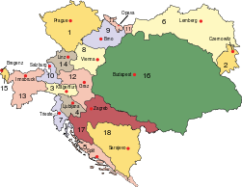

Kingdom of Serbs, Croats, and Slovenes. 1920-1922
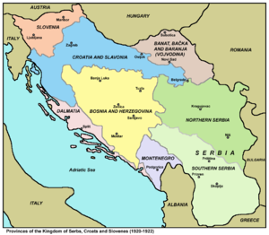
Kingdom of Serbs, Croats, and Slovenes, 1923-2929
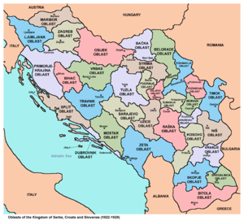

Yugoslavia, 1929-1939
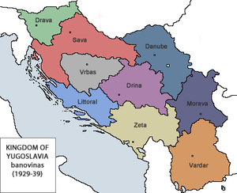

Croatia, province of Yugoslavia, 1939
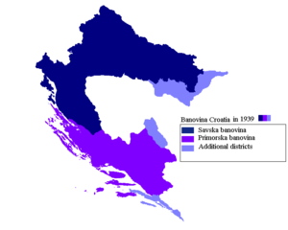

Yugoslavia, 1946-1991

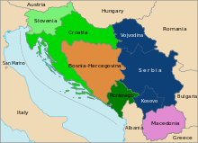

Successor states of Yugoslavia, 1992-

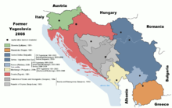
Soviet Union, 1989
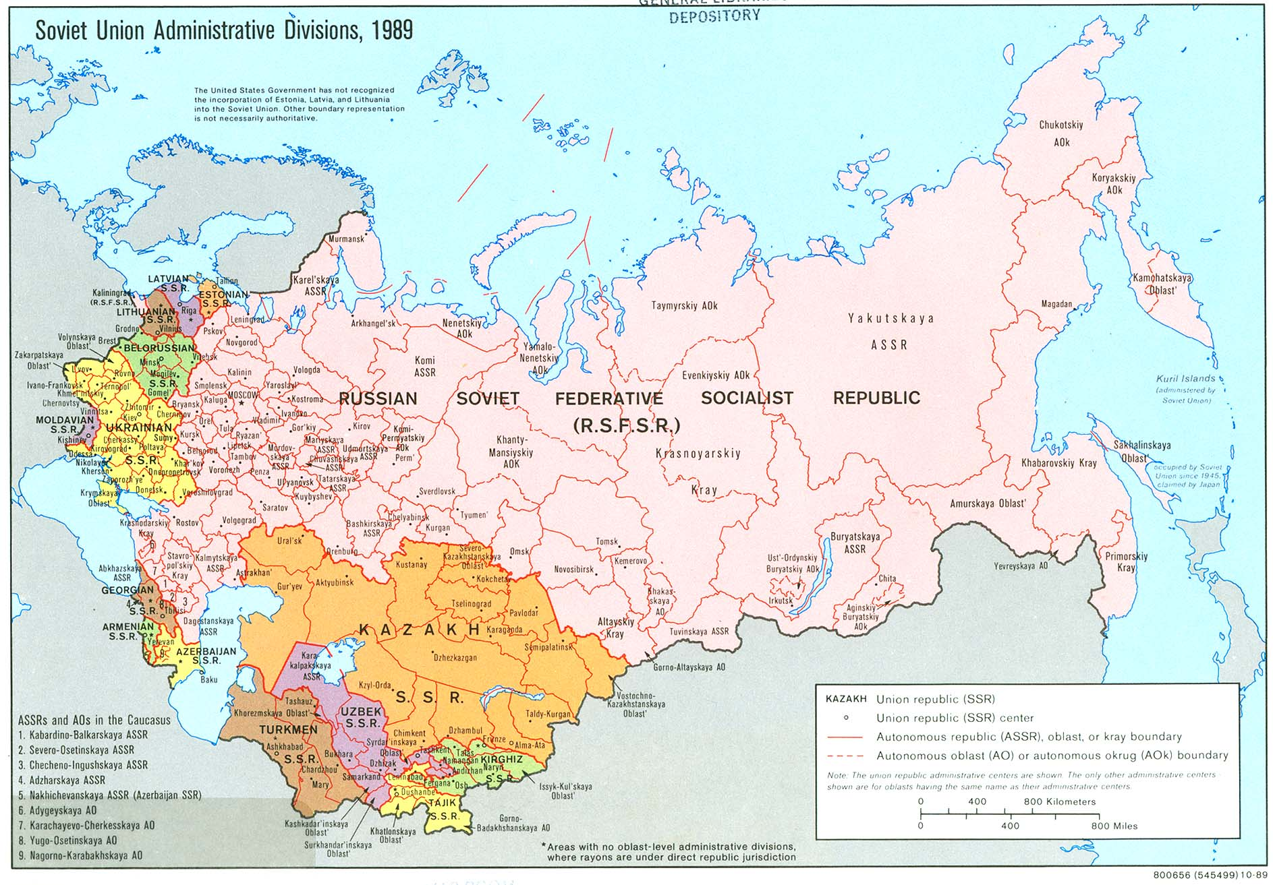

Russia, 1922
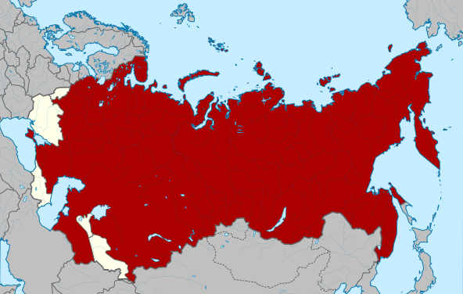

Russia, 1924
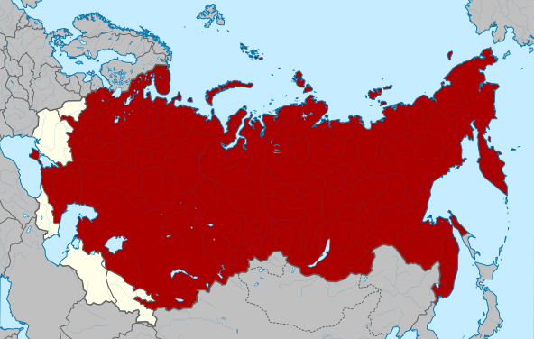

Russia, 1929
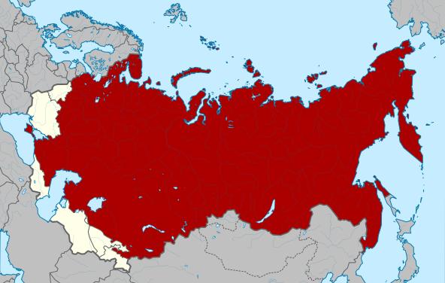

Russia, 1936
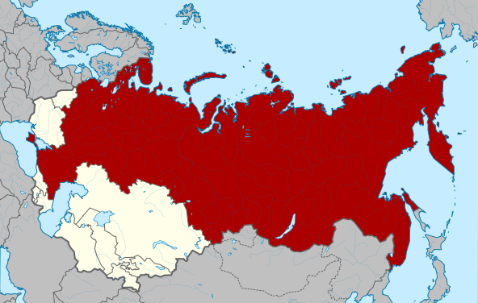

Russia, 1940
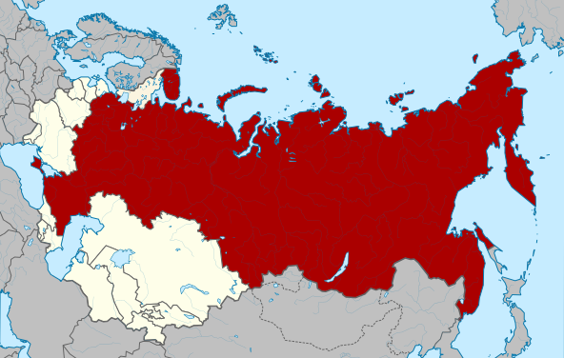

Russian Federation, 1993 -
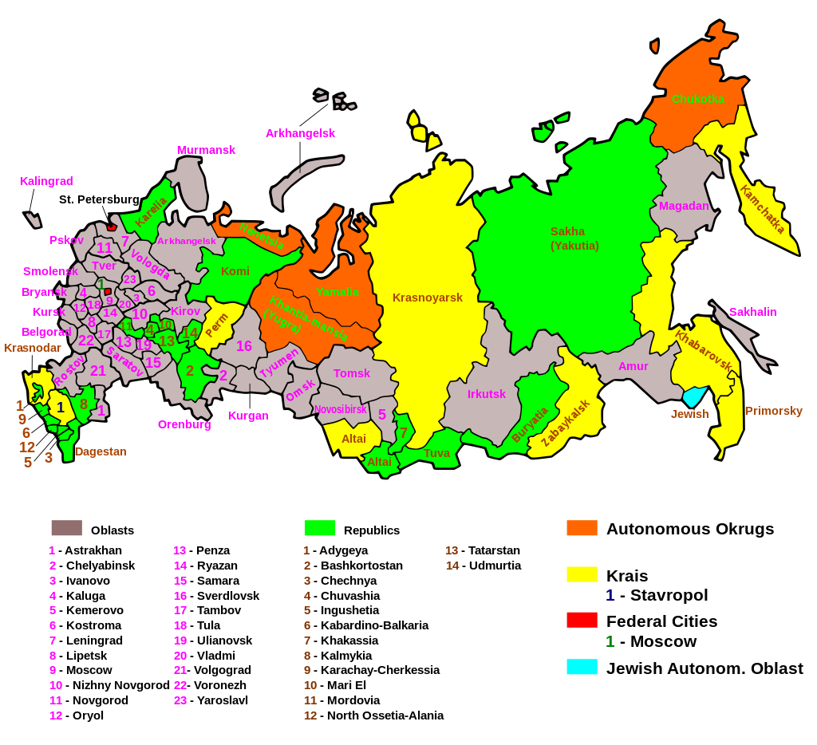

Appendix 2: Printing Money

The Yugoslav Case
I need to write a paper on the 1980s and the crisis of socialism with the emphasis on the stagflation in Yugoslavia. I wrote a paper on the crisis and on the Yugoslav macroeconomic policies already in 1982. The centre of the crisis was the workout of the foreign debt. The main instrument through the decade was rising inflation as the consequence of continuous devaluation with the aim to improve the trade balance and thus achieve solvency.
It is not important here, but it helps to remove possible misunderstandings to point out that the foreign debt to GDP ratio was not really all that high – below 40 percent in all probability. After the introduction of reforms in December of 1989, it took just a year or so with fixed exchange rate regime and liberalisation of foreign investment to buy almost the entire debt back ahead of time.
So, it is not really the level of the debt that matters.
But then the country collapsed. It did not disintegrate for economic or financial reasons as I argued in my book on Why Do Countries Break Up? The Case of Yugoslavia. There was, however, at the end of 1990, an episode of money printing which provided for a scandal and influenced the politics of the break-up. The role of scandals in politics is an interesting topic by itself, but that is for another time (crisis is a scandal).
In any case, this episode was important because the run on the foreign currency reserves through money printing was perpetrated by the state, Serbia, not the federal government or the central bank. Then the foreign currency savings of the population were frozen and effectively confiscated.

Comparison with the Asian Crisis
The early 1980s Yugoslav foreign debt crisis has some similarities with the Asian Crisis of the late 1990s. In both cases, the countries favoured foreign debt over direct investment. That increased the sensitivity of the corporate balance-sheets to rising interest rates. Not because there is some inherent advantage of foreign direct investments over foreign debt, as their ratio does not matter due to Miller-Modigliani Theorem. But because the distribution was skewed towards debt due to legal restrictions on direct investments from abroad. Thus, debt accumulation was encouraged, which is to say that it was overpriced or that the interest rate was low.
Once the actual, in the Yugoslav case, or the expected, as in the Asian case, interest rates increased due to actual or respectively announced FED’s policy, with the intended monetary regime change, the rebalancing of debt versus direct investments exposure was needed. Which led to the stop of foreign debt financing and thus to the exchange rate crisis in both cases and then to the financial crisis and finally to the crisis of the real economy.
The Yugoslav crisis was more difficult to deal with because of the quite unbalanced foreign trade with the trade deficit being much higher than in the Asian countries going through the crisis. And the institutional and the policy adjustment was much more difficult to engineer given the nature of the political regime.
Even just the introduction of the domestic capital market might have been sufficient to work out the foreign debt with the IMF support. But that meant some kind of privatisation, e.g. through the distribution of shares, which required political change.
Politically, democratisation would have been the right political change, but that was unappealing to the ruling party or rather to the ruling parties of the federal states and provinces. If Yugoslavia had just been a Communist dictatorship, rather than a federalised Communist dictatorship, it might have been able to democratise like the countries in the Soviet Block.
Federalism in this respect meant that the states were liable for their respective shares of the foreign debt, not the federal government. And every proposal for pulling together their fiscal responsibility for the public debts met with the rejection for fear of the formation of a transfer union.
Near the end, in 1988, the debt was mutualised to secure yet another IMF programme and financial support, but the political unity was already lost.

Sims’ Paper Money
In any case, how helpful can money printing be in a public debt crisis?
Sims in Paper Money 2015 argues for the distinction between nominal and real money. E.g. between money the government can print and the money like gold or foreign money that it cannot. It need not default on debt in nominal money, but it might have to when debt is in real money.
The distinction is not altogether as clear cut as he makes it, because he is in fact arguing that nominal money, the money printed at will, needs fiscal backing even in the absence of real money in order for the price level to be determined.
In the Yugoslav case, the fiscal backing was either lacking or was removed by secessionist member states. That is a useful example because Sims discusses the EU or rather the European Monetary Union as such a case – where fiscal backing can be denied making euro the real money rather than the nominal one for the member states.
His discussion of the EU, I think, is marred by the common mistake of treating the monetary union as a fixed exchange rate regime, though Sims does that inconsistently as he indeed acknowledges that the European monetary union does supply or certainly could supply its members with nominal money.
It is the fiscal backing that is uncertain.
But, apart from that, the argument that nominal money needs at least the minimal fiscal backing is useful to the understanding of debt defaults; both of defaults on debts in nominal as well as real money (most often in foreign currency).
As an aside, it is to be noted that the so-called Modern Monetary Theory or Post-Keynesian Monetary Theory also relies on the support of taxation to determine the price level.

The Russian Case
The episode to start with is Russia in 1998. They decided to default on their rouble denominated government debt. Why?
They could have printed as many roubles as needed. Russia’s central bank was losing foreign currency reserves. In order to stop the haemorrhaging, the central bank kept hiking the interest rate, which however proved self-defeating.
The point of the ever-higher interest rate on treasury bills was to reinforce the assurance that there was no lack of supply of roubles at the fixed exchange rate. Except that, the supply of roubles being unlimited, there was money to be made by demanding ever higher interest rate to hold on to roubles.
One notes, as an aside, that Russia had been running a trade surplus for some time up to the crisis of 1998. So, there was no reason to devalue to correct the trade balance.
So, one might want to argue that Russia could have printed as many roubles as it wanted had it had a floating exchange rate regime. And thus, would not have needed foreign currency reserves, i.e. real money. Which would be wrong.
During the crisis, as public revenues continued to decline, and with the central government looking ever weaker and more conflicted, with public revenues shrinking as the printing of money sped up, it increasingly looked as if there was not going to be any fiscal support for the monetary policy which was pursued.
And indeed, it was in the end denied with the government defaulting on the debt in its own
paper money. This was unexpected precisely because the debts were in nominal money, which could be supplied in unlimited quantities. So why default?

The Swedish Case
Compare this case with Sweden in 1992. The central bank was defending the fixed exchange rate of the krona by hiking the overnight interest rate on government debt ever higher. The overnight rate reached 500 percent at one point, if memory serves. The central bank was in effect promising to print as many kronor as needed to keep the demand for krona up to stop the loss of foreign currency reserves. The central bank was issuing a threat to speculators – you will lose heavily once the tide turns and interest rates drop dramatically.
Until the central bank gave up and stopped standing in the way of devaluation. As the consequence, the banking system collapsed. And later, there was a change in the monetary regime to that of inflation targeting. Which is clearly not the one in which the central bank can supply money in unlimited quantity.
It is important to mention here that it was not the case that the foreign currency reserves were not plentiful enough. In the exchange rate crisis, the level of foreign currency reserves is not the ultimate insurance of the stability of the fixed exchange rate. Once interest rate needs to be hiked ever higher, the costs to economic activity start to increase and even without the loss of reserves, it does not make sense to hang on to the fixed exchange rate.
The alternative to higher interest rates is indeed the fiscal backing, i.e. the adjustment in the budget to achieve primary surplus, perhaps over few years, which is precisely the required cost
to economic activity.
Sims argues that fiscal backing is needed also with the inflation targeting, floating exchange rate regime, otherwise the Taylor rule or rather the Taylor Principle, which support inflation targeting, also fail to determine the price level.

The Difference
The difference between Russia and Sweden was that the former country’s government decided to default on government’s debt in its own currency. Sweden judged that defaulting would be worse than honouring its debts, in its own and in foreign currency, though they ballooned with the devaluation. Russia calculated differently. Without going into the details of both stories, the point here is that printing money is not always better than defaulting.
One reason is that discussed by Sargent and Wallace 1984. Without foreign currency reserves in the central bank, the public will switch from domestic to foreign currency. This is clearly seen in the hyperinflations, which Sargent and Wallace studied. The money balances corrected for inflation basically go to zero as money is being printed ever faster to make the public want to hold it. In the process, foreign money becomes the money. Giving up on the fixed exchange rate does not help, as long as there is not some limit to money printing.
Put simply, devaluation or the change in the exchange rate regime may prove to be as costly as the defence of the fixed exchange rate – while defaulting on foreign debt may be the least costly way out of an exchange rate crisis. Though, afterwards, fiscal backing will still be needed to determine the price level.
To see this, a simple idea of currency crisis will be useful. Any generation of the theory will do, so take Krugman’s original argument. So, why did ever higher interest rate succeed, until it did not, to sustain the refinancing of the public debt? Because of expected devaluation after which there is money to be made by buying back cheaper, in foreign currency, government debt. Which makes defaulting on the debt in own currency attractive.
One deficiency of Sims’ distinction between nominal and real money can also be seen in the Russian debt crisis. Debts in local currencies are substitutes in the international capital market. So, the effects of devaluation as well as of default spill over. Sims likens the nominal money to equity, which indeed is what makes the difference between debt and equity financing in the Miller-Modigliani set up because there is no fixed nominal value to the equity unlike in the case of debt. So, bankruptcy makes a difference.
But of course, the stock market can crash. Which is what happened in the emerging international capital market or was prevented to happen in the US by massive intervention by the FED after Russia defaulted on its debt.
It is important to see why. While it is true that nominal money is like equity rather than like debt, which is to say is default free as its value can be changed through printing, each country’s debt is close substitute to other countries’ debts so it is subject to arbitrage in international financial markets. Which was the basis for the investment strategy of the Long-Term Capital Management hedge fund which almost crashed the US financial markets when Russia defaulted on its debt.
So, for nominal money to be as different from real money as Sims makes them to be, it would have to be inconvertible. Otherwise, it is not like equity as it can be defaulted on. Alternatively, the international currency market would have to in effect transform nominal money into real and allow for defaults. As in Friedman 1948, I think.

Chervonets
The first case I looked at long time ago was that of Soviet Russia in 1922. When the government introduced the chervonets – the hard or real money. With the explicit aim to go back to the gold standard. Obviously, gold is not something that the central bank can print. So, the need for real money besides the nominal one was recognised. The need was that of determining the price level, i.e. stopping hyperinflation.
The story of chervonets is not simple, and it is not important here. The point of the chervonets being that even if domestic currency is not substituted with the foreign one, it will be substituted with commodity money, e.g. by gold.
One anecdote to note is Lenin’s belief that there is nothing as destructive of the system they indeed wanted to destroy but the debasement of the currency. He, if I remember correctly, celebrated the moment when Russia’s inflation outpaced the one during the Paris Commune as the indicator of the radicalism of the revolution.
It is interesting to note that Russian economists were quick to point out the need for real money. Kondratiev published a paper, I believe in 1921, on the limits of seigniorage, Novozhilov on shortages in 1924, and there is the very good history of early monetary policy by Yurovsky (if I remember correctly the first edition was in 1924).
So, the idea that a country with its own money cannot or should not default is wrong both theoretically and as a matter of history.
Another anecdote to note is that of Mr. Avramović saying that he fashioned the stabilisation policy after the example of the chervonets in Serbia in 1994. The hyperinflation was indeed so fast that redenomination of the dinar and the introduction of fixed exchange rate 1 for 1 with the real money, which was the Deutsch mark, stopped inflation cold overnight. However, the success was short lived because there was no credible fiscal backing, as became clear already at the end of the same year.

Fiscal Backing
What is fiscal backing? It is just the intertemporal budget constraint of the government. Current budget deficits will be financed by future budget surpluses (net of interest payments, i.e. these are primary surpluses). These future surpluses, Sims argues, need not be large enough to either eliminate or reverse the growth of public debt, certainly not in a very short period of time. They can be as small as possible. They will, however, limit the growth of money printing and thus determine the price level or the rate of inflation. The public debt, however, can be as high or as low as needed.
So, the fiscal backing substitutes for real money. If a government cannot commit to fiscal surpluses to cover the public debt, foreign money is the alternative source of real money with the exchange rate setting the price level.
Sims writes that nominal debt is like equity: “Real sovereign debt promises future payments of something the government may not have available — gold, under the gold standard, Euros for individual country members of the EMU, dollars for developing countries that borrow mainly in foreign currency. Nominal sovereign debt promises only future payments of government paper, which is always available. Both types of debt must satisfy the equilibrium condition that the real value of the country’s debt is the discounted present value of future primary surpluses — revenues in excess of expenditures other than interest payments. But if an adverse fiscal development increases debt, the increased real debt will require increased future primary surpluses, whereas with nominal debt there are two other ways to restore balance — inflation, which directly reduces the real value of future commitments, and changes in the nominal interest rate, which will change the current market value of long term debt.
Obviously outright default on nominal debt is much less likely than default on real debt. So long as the country is capable of generating any positive stream of primary surpluses, its debt will have non-zero real value. But if debt is real and the country finds itself unable to maintain primary surpluses above its predetermined real debt service commitment, it must default, even if in absolute terms it is running substantial primary surpluses.”
He goes through three monetary models to highlight the point of fiscal backing.
(i) Samuelson’s overlapping generations with storage, where storage is the real, commodity money which substitutes for worthless nominal money in the absence of fiscal backing of government bonds (Samuelson suggests the constitutional solution which I discuss in my Fiscal Rules and Councils).
(ii) Taylor rule based monetary policy with the Taylor Principle (react more than one-to-one with the interest rate adjustments to change in inflation), which may blow up the economy (hyperinflation) or become irrelevant at zero interest rate. So, it will fail to set the price level if not backed by fiscal policy.
(iii) Barro’s argument for improved timing of taxation with public borrowing as alternative way to finance the budget, which of course needs fiscal backing, though does not require a public debt target.
He concludes: “The kinds of models that have been the staple of undergraduate macroeconomics teaching, with price level determined by balance between “money supply” and “money demand”, and money supply described using the “money multiplier”, are obsolete and provide little insight into the policy issues facing fiscal and monetary authorities in the last few years. There are relatively simple models available, though, that could be taught in undergraduate and graduate courses and that would allow discussion of current policy issues using clearer analytic foundations.”

Euro
Sims discusses the lack of fiscal backing which can come from political indecisiveness. This is not the new argument for him as he relied on it in his discussion with Sargent (and earlier in Macroeconomics and Reality 1980). Sargent’s model at the time was the one of the advisor to a benevolent dictator who chooses between current inefficient policy set-up and the efficient one which is a Pareto improvement over the former. Sims’ model has been that of changing policies as the consequence of political competition. Within that, political indecisiveness is one possible state of affairs. As in the EU.
The argument he makes is really about a country like Greece which cannot run primary surpluses high enough to avoid defaulting on its debt in euro, which is its nominal money which it cannot print, thus being in fact its real money. Compare the situation in the US. There the FED has also failed to determine the price level because there is a stalemate in the Congress over fiscal policy or rather there is indecisiveness when it comes to raising taxes. Thus, fiscal backing of monetary policy is not assured.
In the EU, the EU budget does not have the same role as the EU cannot raise taxes. So, it cannot provide fiscal backing to the European central bank, even though the EU budget is balanced at all times. Sims’ discussion of the EU is somewhat sketchy, though he goes into some detail about the monetary arrangement or the set-up of central banking. His real point is not so much that there is no fiscal backing or that there is no money printing, i.e. monetisation of public debts of member states. Though he treats member states as if they were countries with fixed exchange rates which use foreign money as their real money, this is not how he treats them when he discusses their fiscal support for the common currency.
His argument is that it is likely that fiscal backing is not necessarily forthcoming or will continue to be forthcoming from member states, which is the consequence – he does not say that but it is clearly the implication – of the fact that the EU budget relies on contributions rather than on taxation. So, member states may have to default in some fashion on their debts, as has been the case with Greece.
The interesting comparison is with Yugoslavia with the federal budget which also relied on contributions and not on taxation. The central bank printed money and indeed was basically bankrupt (had high negative worth), but could not be recapitalised, and more importantly the federal government could not promise fiscal backing by running primary surpluses as it could not tax and thus defaulted on its foreign currency debt.
So, Sims’ argument could be that EU may choose to disintegrate rather than form some kind of a fiscal union. The US case is a different one – it may be stuck in secular stagnation. In both cases, the respective central banks’ monetary policies cannot determine the price level.
So, printing money without fiscal backing cannot determine the price level. Put differently, printing money by itself is neither monetary nor fiscal policy instrument.

References and literature
Alchian, A. (1977), “Why Money?”, Journal of Money, Credit and Banking 9: 133-140.
Alesina, A., R. Perotti, E. Spolaore (1995), “Together or Separately? Issues on the Costs and Benefits of Political and Fiscal Unions.” European Economic Review 39: 751-758.
Alesina, A., E. Spolaore (1997), “On the Number and Size of Nations”, The Quarterly Journal of Economics 112: 1027-1056.
Alesina, A., R. Barro (2002), “Currency Unions”, The Quarterly Journal of Economics 117: 409-436.
Alesina, A., R. Barro, S. Tenreyro (2002), “Optimal Currency Areas”, NBER Macroeconomic Annual 17: 301-356.
Alesina, A., E. Spolaore (2003), The Size of Nations, MIT Press.
Alesina, A., I. Angeloni, F. Etro (2005), “International Unions”, The American Economic Review 95: 602-615.
Bagehot, W. (1873), Lombard Street. Many editions.
Banerjee, A. V., E. S. Maskin (1996), „A Walrasian Theory of Money and Barter“, The Quarterly Journal of Economics 11: 955-1005.
Barro, R. (1979), “On the Determination of the Public Debt”, Journal of Political Economy 87: 940-971.
Benati, L., C. Goodhart (2011), “Monetary Policy Regimes and Economic Performance: The Historical Record, 1979-2008” in B. M. Friedman, M. Woodford (eds.), Handbook of Monetary Economics 3B: 1159-1236. Elsevier.
Bolton, P., G. Roland (1997), “The Breakup of Nations: A Political Economy Analysis”, The Quarterly Journal of Economics 112: 1057-1090.
Bordo, M. D., A. Markiewicz, L. Jonung (2011), “A Fiscal Union for the Euro: Some Lessons from History”, NVER Working Paper 17380.
Bordo, M. D., A. J. Schwartz (1999), “Monetary Policy Regime and Economic Performance: The Historical Record” in J. B. Taylor, M. Woodford (eds.), Handbook of Macroeconomics 1A: 149-234. Elsevier.
Boughton, J. M. (2012), Tearing Down Walls: International Monetary Fund 1990-1999. International Monetary Fund.
Brunnermeier, M., Y. Sannikov (2011), “The I Theory of Money”, working paper.
Buchanan, J. (1965), “An Economic Theory of Clubs”, Economica 32: 1-14.
Buchanan, J. (1971), The Limits of Liberty: Between Anarchy and Leviathan. University of Chicago Press, 1975.
Buchanan, J. (1990), “An American Perspective on Europe’s Constitutional Opportunity”, Cato Journal 10: 619-629.
Buchanan, J. (1995), “Federalism as an Ideal Political Order and an Objective for Constitutional Reform”, Publius: The Journal of Federalism 25: 19-27.
Buchanan, J., R. Faith (1987), “Secession and the Limits to Taxation: Toward a Theory of Internal Exit”, American Economic Review 77: 1023-1031.
Canzoneri, M., R. Cumbay, B. Diba (2011), “The Interaction between Monetary and Fiscal Policy”, Chapter 17 in Benjamin M. Friedman & Michael Woodford (eds.), Handbook of Monetary Economics Vol. 3B. Elsevier.
Casella, A. (1992), “Participation in a Currency Union”, The American Economic Review 82: 847-863.
Casella, A., B. Frey (1992), “Federalism and Clubs: Towards an Economic Theory of Overlapping Political Jurisdictions”, European Economic Review 36: 639-646.
Clarida, R., J. Gali, M. Gertler (2001), „Optimal Monetary Policy in Open and Closed Economics: An Integrated Approach“, American Economic Review Papers and Proceedings 91: 248-252.
Clarida, R., J. Gali, M. Gertler, “A Simple Framework for International Monetary Policy Analysis”, Journal of Monetary Economics 49: 879-904.
Cochrane, J. (2005), “Money as Stock”, Journal of Monetary Economics 52: 501–528.
Cohen, B. J. (2000), “Beyond EMU: The Problem of Sustainability” in B. Eichengreen, J. Frieden (eds.), The Political Economy of European Monetary Unification. Westview Press, 2001: 179-204.
Conway, P. (1995), Currency Proliferation: The Monetary Legacy of the Soviet Union. Essays in International Finance No. 197. Princeton University Press.
Curdia, V., M. Woodford (2011), “The Central-Bank Balance Sheet as an Instrument of Monetary Policy”, Journal of Monetary Economics 58: 54-79.
Dabrowski, M. (1995), “The Reasons of the Collapse of the Ruble Zone”, CASE Network Studies and Analyses No. 58.
Desmet, K., M. Le Breton, I. Ortuna-Ortin, S. Weber (2011), „The Stability and Breakup of Nations: A Quantitative Analysis“, Journal of Economic Growth 16: 183-213.
Diamond, D.W, P. H. Dybvig (1983), "Bank runs, deposit insurance, and liquidity", Journal of Political Economy 91: 401–419.
Diamond, D. W., R. G. Rajan (2006), “Money in a Theory of Banking”, American Economic Review 96: 30-53.
Dornbusch, R. (1994), Post-Communist Monetary Problems: Lessons from the End of the Austro-Hungarian Empire. International Center for Economic Growth.
Dornbusch, R. (1997), “Fiscal Aspects of Monetary Integration”, American Economic Review Papers and Proceedings 87: 221-223.
Eddie, S. (1977), “The Terms and Patterns of Hungarian Foreign Trade, 1882-1913”, Journal of Economic History 37: 329-358.
Eddie, S. (1982), Limits on the Fiscal Independence of Sovereign States in Customs Union: “Tax Union" Aspects of the Austro-Hungarian Monarchy, 1868-1911”, Hungarian Studies Review 9: 7-28.
Eddie S. (1989), “Economic policy and economic development in Austria-Hungary, 1867-1913” in Cambridge Economic History of Europe, Vol. 8.
Eichengreen, B. (1990), “One Money for Europe? Lessons from the U.S. Currency Union”, Economic Policy 5: 119-186.
Eichengreen, B. (1996), A More Perfect Union? The Logic of Economic Integration. Essays in International Finance No. 198.
Evans, G. W., S. Honkapohja, (2007) “Policy Interaction, Learning and the Fiscal Theory of Prices”, Macroeconomic Dynamics 11: 665-690.
Findlay, R. (1996), “Towards a Model of Territorial Expansion and the Limits of Empire” in M. Garfinkel, S. Skaperdas (eds.), The Political Economy of Conflict and Appropriation. Cambridge University Press, 41-56.
Friedman, D. (1977), “A Theory of the Size and Shape of Nations”, Journal of Political Economy 85: 59-77.
Friedman, M. (1948), “A Monetary and Fiscal Framework for Economic Stability”, The American Economic Review 38: 245-264.
Friedman, M. (1953), “The Case for Flexible Exchange Rates”, in Essays in Positive Economics. University of Chicago Press, 157-203.
Friedman, M. (1961), “The Lag in Effect of Monetary Policy”, Journal of Political Economy 69: 447-466.
Friedman, M. (1968), “The Role of Monetary Policy”, American Economic Review 58: 1-17.
Friedman, M. (1969), “The Optimum Quantity of Money”, in The Optimum Quantity of Money and Other Essays. Chicago: Aldine Publishing Co., 1-50.
Friedman, M. (1971), A Theoretical Framework for Monetary Analysis. NBER.
Friedman, M., A. Schwartz (1987), “Has Government Any Role in Money?” in A. Schwartz (ed.), Money in Historical Perspective. Chicago University Press, 289-314.
Friedman, M. (1997), “John Maynard Keynes”, Federal Reserve Bank of Richmond Quarterly Review 83: 1-23.
Garber, P. M., M. G. Spencer (1994), The Dissolution of the Austro-Hungarian Empire: Lessons for Currency Reform. Essays in International Finance No. 191. Princeton University Press.
Gligorov, V. (1992-2012), Rights and Choices: Arrow and Rawls. Unpublished.
Gligorov, V. (1994), Why Do Countries Break Up? The Case of Yugoslavia. Acta univesitatis upsaliensis.
Gligorov, V. (1995), “What if They Will Not Give Up?”, East European Politics & Societies September 9: 499-512.
Gligorov, V. (1997), “Benjamin Constant and Carl Schmitt go to Russia”, Constitutional Political Economy 4: 271-282.
Gligorov, V. (2007), “A Kantian Idea of Sovereignty” in H. Swoboda, C. Solioz (eds.), Conflict and Renewal: Europe Transformed: Essays in Honour of Wolfgang Petritsch. Nomos, 196-208.
Gligorov, V. (2011), “What Price Nationalism?” wiiw Policy Note 5.
Gligorov, V. (2012a), “Deepening and Widening – Enlargement and the Integration Capacity of the EU: Past Experience and Future Prospects (concepts, processes, methods, and lessons)”, Peščanik.
Gligorov, V. (2012b), “Five Easy Pieces on Keynes”, Peščanik.
Gligorov, V. (2012c), Neoclassicism in the Balkans and Other Essays. Civis.
Goodhart, C. A. E. (1998), “The Two Concepts of Money: Implications for the Analysis of Optimal Currency Areas”, European Journal of Political Economy 14: 407-432.
Goodhart, C. A. E. (1995), “The Political Economy of Monetary Union” in P. B. Kenen (ed.), Understanding Interdependence: The Macroeconomics of the Open Economy. Princeton University Press, 448-508.
Gordon, R. H. (1982), “An Optimal Taxation Approach to Fiscal Federalism”, NBER Working Paper No. 1004.
Gordon, D. B., E. M. Leeper (2006), “The Price Level, the Quantity of Money, and the Fiscal Theory of the Price Level”, Scottish Journal of Political Economy 53: 4-27.
Gourinchas, P-O., M. Obstfeld (2012), “Stories of the Twentieth Century for the Twenty-First”, American Economic Journal: Macroeconomics 4: 226-265.
Gurley, J. G, E. S. Shaw (1960), Money in a Theory of Finance. Brookings Institution.
Hayek, F. (1937), Monetary Nationalism and International Stability. London: Longmans.
Hayek, F. (1948, originally 1939), “The Economic Conditions of Inter-state Federalism”, chapter 12 in Individualism and Economic Order. The University of Chicago Press.
Hayek, F. (1976), Choice in Currency: A Way to Stop Inflation. The Institute of Economic Affairs.
Hayek, F. (1976; third edition 1990), Denationalisation of Money. The Institute of Economic Affairs.
Helleiner, E. (1999), “Denationalising Money? Economic Liberalism and the ‘National Question’ in Currency Affairs” in E. Glibert, E. Helleiner (eds.), Nation-States and Money: The Past, Present, and Future of National Currencies. Routlage, 139-157.
Hicks, J. (1935”, “A Suggestion for Simplifying the Theory of Money”, Economica, New Series 2: 1-19.
Hicks, J. (1989), A Market Theory of Money. Oxford: Clarendon Press.
Horvat, B. (1083), Political Economy of Socialism: Marxist Socialist Theory. Routledge.
Hume, D. (1741-1742), “On Money” in Essays (any edition).
Jeanne, O. (2000), Currency Crisis: A perspective on Recent Theoretical Developments. Special Papers in International Economics No. 20.
Judt, T. (2009), “What is Living and What is Dead in Social Democracy?”, The New York Review of Books 56, number 20.
Kirsanova, T., C. Leith, S. Wren-Lewis (2009), “Monetary and Fiscal Policy Interaction: The Current Consensus Assignment in the Light of Recent Developments”, Economic Journal 119: F482-F496.
Kiyotaki, n., R. Wright (1989), “On Money as a Medium of Exchange”, Jorunal of Political Economy 97: 927-954.
Krugman, P. (1992), “Policy Problems of a Monetary Union” chapter 11 in Currencies and Crises. MIT Press.
Lane, P. (2001), “The New Open Economy Macroeconomics: A survey”, Journal of International Economics 54: 235-266.
Lagos, R. (2008), “Inside and Outside Money” in Steven N. Durlauf and Lawrence E. Blume (eds.), The New Palgrave Dictionary of Economics. Second Edition. Palgrave Macmillan.
Leeper, E. (1991), “Equilibria under ‘Active’ and ‘Passive’ Monetary and Fiscal Policies”, Journal of Monetary Economics 27: 129-147.
Lindert, P. (2004), Growing Public Vol. I-II. Cambridge University Press.
McCallum, B. T. (1999), “Theoretical Issues Pertaining to Monetary Unions”, NBER Working Paper 7393.
McCallum, B. T., E. Nelson (2006), "Monetary and Fiscal Theories of the Price Level: The Irreconcilable Differences", Tepper School of Business, Paper 281.
Menger, C. (1892, 2009), On the Origin of Money. Ludwig von Mises Institute.
Mundell, R. (1968), International Economics. Macmillan.
Mundell, R, "Uncommon Arguments for Common Currencies", in H. Johnson, A. Swoboda (eds.), The Economics of Common Currencies. London: George Allen & Unwin Ltd.: 114-132.
Mundell, R. (1973), “A Plan for a European Currency", in H. Johnson, A. Swoboda (eds.), The Economics of Common Currencies. London: George Allen & Unwin Ltd.: 143-173.
Obstfled, M. (2011), “International Liquidity: The Fiscal Dimension”, Bank of Japan Monetary and Economic Studies, 33-48.
Obstfeld, M. (2012), “Does the Current Account Still Matter?”, American Economic Review 102: 1-23.
Obstfeld, M., K. Rogoff (1995), “Exchange Rate Dynamics Redux”, Journal of Political Economy 103: 624-660.
Persson, T., G. Tabellini, (1996a), “Federal Fiscal Constitutions: Risk Sharing and Redistribution”, Journal of Political Economy 104: 979-1009.
Persson, T., G. Tabellini (1996b). “Federal Fiscal Constitutions: Risk Sharing and Moral Hazard”, Econometrica 64: 623-646.
Renihart, C., K. Rogoff (2009), This Time is Different: Eight Centuries of Financial Folly. Princeton University Press.
Rodrik, D. (2012), “Who Needs the Nation State?”, CEPR Discussion Paper No. 9040.
Ruta, M. (2005), “Economic Theories of Political (Dis)Integration”, Journal of Economic Surveys 19: 1-21.
Sala-i-Martin, X. J. Sachs (1992), “Fiscal Federalism and Optimum Currency Areas: Evidence for Europe from the United States, NBER Working Paper 3855.
Sapir, A. (2001), Domino effects in Western European regional trade, 1960-1992. European journal of political economy, 377-388.
Sargent, T. (2008), “Evolution and Intelligent Design”, American Economic Review 98: 5-37.
Sargent, T. (2012), “United States then, Europe now”, https://files.nyu.edu/ts43/public.
Schularick, M., A. M. Taylor (2012), “Credit Booms Gone Bust: Monetary Policy, Leverage Cycles, and Financial Crisis, 1870-2008”, American Economic Review 102: 1029-1061.
Schumpeter, J. A. (1918, 1991). "The Crisis of the Tax State", in Richard Swedberg (ed.), The Economics and Sociology of Capitalism, 99-140. Princeton University Press.
Sims, C. A. (2001), "Fiscal Consequences for Mexico of Adopting the Dollar," Journal of Money, Credit, and Banking 33: 597-616.
Tilly, C. (1985), “War Making and State Making as Organized Crime”, in P. Evans, D. Rueschemeyer, T. Skocpol (eds.), Bringing the State Back In. Cambridge University Press, 169-186.
Tiebout, C. (1956), “A Pure Theory of Local Expenditures”, Journal of Political Economy 64: 416-424.
Tilly, C. (1992), Coercion, Capital, and European States, Ad 990-1992. Blackwell.
Wallace, H. (2010), Policy-making in the European Union. Oxford University Press.
Wallace, N. (1981), “A Modigliani-Miller Theorem for Open-Market Operations”, American Economic Review 71: 267-274.
Wallace, N. (1988), “A Suggestion for Oversimplifying the Theory of Money”, Economic Journal Supplement Conference Papers 98: 25-36.
Wittman, D. (1991), “Nations and States: Mergers and Acquisitions; Dissolutions and Divorce”, American Economic review Papers and Proceedings 81: 126- 129.
Wittman, D. (2000), “The Wealth and Size of Nations”, Journal of Conflict Resolution 44: 868-884.
Woodford, M. (2001), “Fiscal Requirements for Price Stability”, Journal of Money, Credit and Banking 33: 669-728.
Woodford, M. (2010), “Globalization and Monetary Control” in J. Gali, M. J. Gertler (eds.), International Dimensions of Monetary Policy. University of Chicago Press.

After 1968, Austro-Hungarian Empire looked a lot like Bosnia and Herzegovina after 1995, with two asymmetric constituent parts (the difference being the army of course).
The federation was also asymmetric, though on the Soviet Union rather than Austro-Hungarian model, though some remnants of the latter can be also found in some constitutional arrangements.
Soviet Union was a symmetric federation, but Russian Federation, which was a constituent part of the Soviet Union, was not; it was formally decentralised and in an asymmetric way also. So, Soviet Union was a federation of states and one federation, as was Yugoslavia and also Austro-Hungary. Asymmetry was the rule of political decentralisation. If an analogy is to be drawn to multi-speed Europe, these were multi-speed integrations or disintegrations, which make them somewhat comparable to the EU. It is to be noted that while the member states of Soviet Union had the right to secede, as in Yugoslavia or the EU, political units within Russia or Serbia did not, as is the case with member states of the EU, and possibly of Austrian provinces too. Those are governed by their own respective constitutions or political arrangements.
EU is also asymmetric in a number of ways, with some member states being federations while the other are centralised. Also, there are circles of integration. This contrasts with symmetrical federations or political unions, of which USA is probably the best example; but asymmetry is often characteristic of federations and political unions. Figuring out the distribution of power and influence over policy making on all levels of government tends to be quite complicated (Wallace….).

